CURRICULUM VITAE

GERRY CLARKE – Writer, Producer, Film & TV Director and
International Corporate Communications Consultant

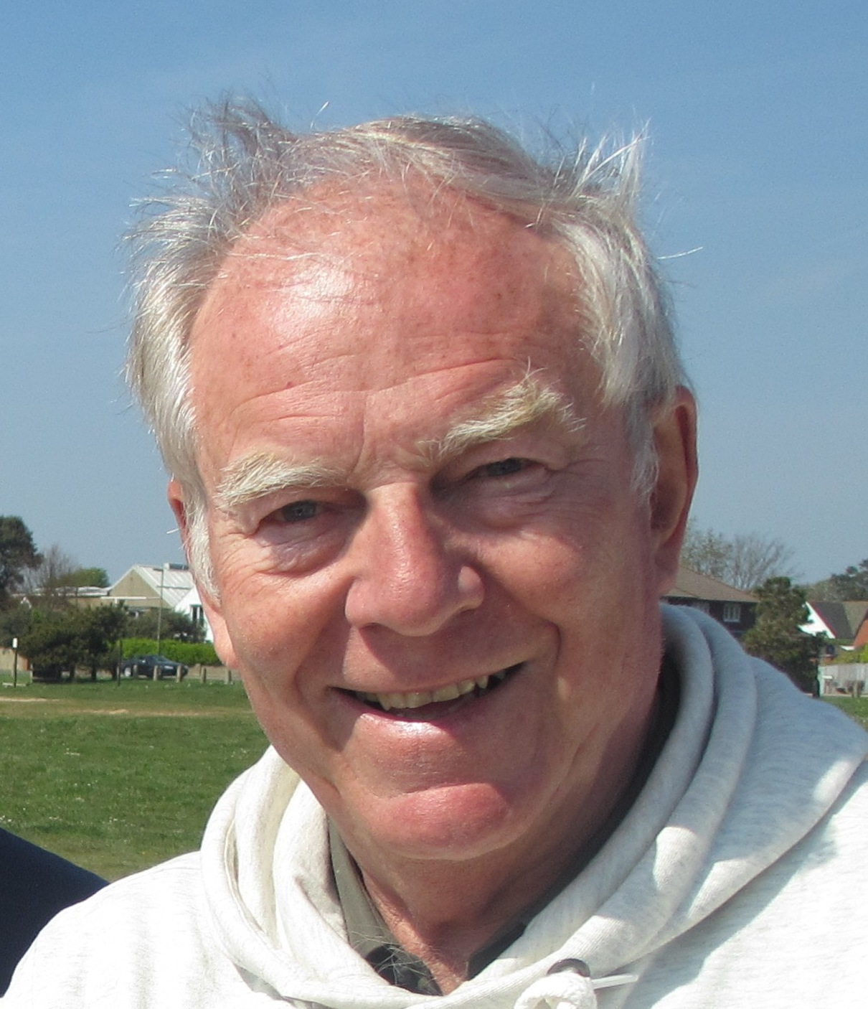

Over thirty five years experience in the organisation and management of
international corporate communications projects, business conferences, exhibitions,
marketing, publicity and PR events. Writer, producer and director of award winning
training and promotional films, videos, multimedia and webTV programmes.
Freelance photojournalist. Music and Arts Festival Director.
Artist, Sculptor and generally a very happy person.

PROFESSIONAL EXPERIENCE

1998 - 2020 FREELANCE COMMUNICATIONS CONSULTANT, VIRTUAL MEDIA

Various creative projects, articles, photographic, video and webTV assignments:-

- Executive TV producer and director World Happiness Project
- Event Director, UK Happiness and Wellbeing Conference at Bournemouth University
- Artist, Sculptor and Creative Director of numerous Art and Entertainment Projects
- Creative Designer of Sculpture Parks, Town Memorials and Gardens of Memory
- Festival Director, Bournemouth Jazz by the Sea Festival and The World Jazz Jamboree
- Organiser of various corporate hospitality and team building events
- Council funded community project to improve appearance of local town and environment
- Event organiser for Heritage Lottery funded Rotary project: Pirates, Castaways and Codfish
- Curator of Art Gallery, Sculpture Garden and Arts & Music Festival at Compton Acres
- Marketing and Public Relations for Compton Acres Gardens and Parkstone Bay Boat Club
- Chairman of Young Environmentalist Challenge Competition for Ferndown Rotary Club
- Arts & Entertainment correspondent for Dorset Publications
- Design and installation of Lottery funded Ferndown Memorial and Garden of Memories
- Creative Scriptwriter and Director of In-Flight destination videos for Virgin Airlines
- International PR consultant for EasiYo, a New Zealand based dairy product manufacturer
- National Parks Authority study for the creation of a new Sculpture Park in the New Forest
- Various lifestyle articles on local events, music, arts and entertainment festivals, property, yachting, travel and tourism for the English speaking community in the French Riviera
- Writer, reporter and interviewer for ABC Television at Cannes Film Festival
- Web editor for international e-zine on global communications for Nortel Networks
- ‘Tech Watch’ column for Time Magazine featuring the latest communications technology
- Feature for Time Magazine about NetAid and impact of the Internet on Global Poverty

1987 - 1998 CHIEF EXECUTIVE OFFICER, VIDEO NEWSREELS LTD

Owner and Director of international company specialising in corporate communications:-

British Telecom - Design and production of video and multimedia programmes for sales promotion, customer awareness, staff motivation and training. Projects include copywriting, event management, roadshows, seminars, exhibition design, conference presentation, print and publicity for BT events and launch of Network BT newsmagazine in the UK and Europe.

Hewlett Packard - Conference organiser for European Management Forum Meeting in the Netherlands. Responsible for venue, guest speakers, conference programme, design and build of stage set, presentation materials, conference print and publicity. Technical support for exhibitions, press and PR events.

European Union - Creation and development of EURO 2010 Health Education programme for use in schools throughout Europe. Project involved writing and producing videos, print and publicity materials in nine languages.

Farmers Newsreel - Regular video newsmagazine featuring the latest in agricultural technology containing news items, interviews and reports on new products and services for farmers.

British Airways - Design and production of sales, marketing and staff training videos dealing with all aspects of the airline’s operations in the UK and around the world. Creator of AIRBYTES, a regular InFlight video newsmagazine featuring the latest in computers and information technology. Programmes sponsored by Intel, Microsoft, Nokia, Motorola, Apple, Compaq and Xerox.

Marks & Spencer, Sainsbury’s, Budgen Stores, Comet and the Kingfisher Group - Staff training and motivational programmes to introduce improved working practises in UK stores.

IBM, 3M, Honeywell, Tandem and Digital - Management of communications projects, conferences and annual reports to staff and shareholders.

Ford Motor Company, Midland Bank, Royal Bank of Scotland and AMP Insurance - Production of promotional, staff training and education videos and TV commercials.

Security World - Design and production of security training and anti terrorist promotional videos for various UK Police Forces and the UK Department of Transport

Travel World - Video newsmagazine featuring the latest developments in the Travel Industry.

Festivals of Britain - Pilot television programme highlighting UK music, arts and cultural festivals.

Various Local Government Authorities and UK Government Departments in the UK - Production of a wide variety of information, promotion and training programmes to communicate a range of government initiatives to the local community, programmes covering education, health and safety, transport, recreation and other local issues.

1973 - 1986 CHAIRMAN AND MANAGING DIRECTOR, AGRIVISUAL LTD

Responsible for the production and implementation of training programmes worldwide.

Under various contracts to the World Bank, Washington - Responsible for writing and producing agricultural training programmes, films, television and radio programmes, training manuals, print and publicity materials to help transfer technology to people living in the Developing World.

Consultant to the United Nations FAO-UNDP - Advising the organisation on the production of training programmes designed to introduce and explain technology to people living in rural areas of the Third World. Guest speaker at various international conferences dealing with agricultural development and farmer communications.

UK Ministry of Overseas Development ODA - Design and supply of film, video, radio and television studio equipment and the training of staff in the production of educational programmes for farmers and people living in rural areas of Kenya.

Cadbury’s and the Cocoa & Chocolate Alliance - Report on improving cocoa production in Ghana.

Under contract to the European Commission, Brussels - Preparation of blueprint and action plan for the introduction and development of training and visit system of extension for improving the flow of information to farmers in various countries in Africa.

Shell/ICI Chemicals/Dow Elanco/Monsanto/Hoechst/Dupont/FMC and Zeneca - Production of award winning films and videos to promote the safe and efficient use of chemicals in the rural environment. Working on various projects in Europe, Africa, Middle East, Asia and S. America.

IEE/Sperry Univac - Producer/Director of 1974 Faraday Lecture film entitled ‘The Social Computer’ - a 60 minute documentary film on the importance of computers in our everyday lives.

1967 - 1973 ESTATE MANAGER, COMMONWEALTH DEVELOPMENT CORPORATION

Seconded to agricultural development projects in Africa and the Caribbean

Mhlume Sugar Company, Swaziland Trainee Manager and Irrigation Agronomist on Sugar Estate

Castle Bruce Estate, Dominica Manager responsible for day to day running of Banana Plantation

ARTICLES, SEMINARS, CONFERENCE PAPERS AND WORKSHOPS

Training and Visit System of Agricultural Extension. UNDP Conference in Cameroon.

Producing Effective Communications for Farmers. Conference Paper and workshop in Brazil

Improving Farmer Communications in the Developing World. FAO/ICP Seminar in Pakistan

Workshop for the Design and Production of Visual Aids in Rural Areas. CEDO workshop Kenya

Past President of Easthampstead Rotary Club and Member of Poole Bay Rotary Club and Ferndown Rotary Club. Chairman Ferndown Town Council Art4All project. 20.01.2020

